The Magnetic Field of the Earth

Ancient mariners believed that somewhere in the North was a magnetic mountain that was the source of attraction for their compasses. It was not until 1600 when Sir William Gilbert, then physician to Queen Elizabeth I, compared the earth to a large spherical lodestone. He maintained that the compass needle was drawn to the planet’s magnetic pole, not to the heavens as everyone else at that time had thought. It was simply a matter of one magnet pulling on another. In simple terms, Gilbert’s model was the earth’s magnetic field was similar to that of a large bar magnet, inclined at a slight angle to the earth’s axis and with its south pole in the northern hemisphere.
In the diagram below to the left, the dashed lines show the magnetic field lines of the earth. At various places a compass has been inserted. The arrows in the compass represent the manner in which the north end of the compass would point. Note that in the northern hemisphere, the compass needles are pointing towards the earth. This is where the south end of a magnet would be. In the southern hemisphere, the compass needles are pointing away from the earth. This is where the north end of a magnet would be.
We will define the north magnetic pole as the pole that is found in the northern hemisphere. This pole acts as though it is a south pole on a bar magnet. The north magnetic pole is so named because it is the location toward which the north end of a compass needle points. The south magnetic pole is the pole that is in the southern hemisphere. This pole acts like the north pole of a bar magnet. The north end of a compass points away from this pole. At the poles, a magnetic compass would just rotate freely.
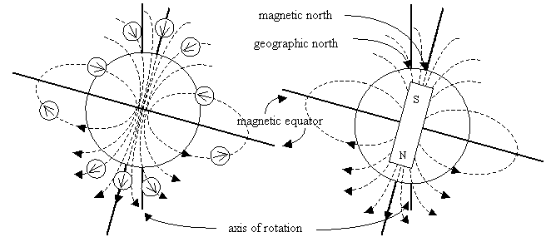
The north geographic pole is that point where the earth’s axis of rotation crosses the surface in the northern hemisphere. The north magnetic pole does not coincide with the north geographic pole, but instead lies in Hudson Bay some 1300 km to the south. The south magnetic pole is located in Antarctica near the Ross Sea. The axis of the fictitious bar magnet and the earth’s rotational axis is about 11.5º.

Magnetic Declination and Magnetic Inclination

A compass needle points towards the earth’s magnetic north pole rather than towards its geographic north pole the north end of its axis of rotation. The angle between magnetic north and geographic north varies from position to position on the earth’s surface and is called magnetic declination. For example, the magnetic declination for Victoria B.C. is 20º east but in St. John’s Newfoundland it is 23º west. This means that a compass needle in Victoria points 23º east of geographic north and a compass needle in St. John’s points 23º west of geographic north. In order to navigate by compass, the angle of declination for a particular location must be known to permit calculation of true north. According to the National Geomagnetism Program, the north magnetic pole is a feature unique to Canada and monitoring its position and motion is of prime importance to Canadian cartography.
As well, the earth’s magnetic field is three dimensional, with both a horizontal and a vertical component. A magnetic compass on a horizontal surface reveals only the horizontal component. The angle between the earth’s magnetic field at any point and the horizontal, is called the magnetic inclination or angle of dip and it is measured with a magnetic dipping needle. A dipping needle is a compass pivoted at the centre of gravity and free to rotate in a vertical plane. When aligned with a horizontal compass pointing north, it will point in the direction of the earth’s magnetic field, and the angle of inclination can be read directly from the attached protractor. At each location on the earth, the magnetic field lines intersect the earth’s surface at a specific angle of inclination. Near the equator, the field lines are approximately parallel to the earth’s surface, and the angle of inclination in this region is close to 0º. At the magnetic pole, the field lines are directed almost straight down into the earth and the angle of inclination is 90º. Thus the angle of inclination varies with latitude. It has been suggested that some animals have the ability to distinguish between magnetic inclination angles and therefore “know” the latitude.
Inclination and declination charts must be revised from time to time because the earth’s magnetic field seems to be slowly changing. It is believed that these changes result from the earth’s magnetic field rotating about the earth’s axis, taking about 1000 years to make a complete rotation.
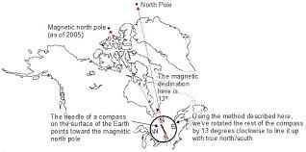
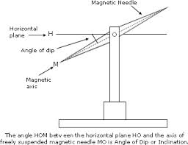

The Magnetosphere and the Auroras

The magnetosphere is a region of the upper atmosphere beyond approximately 200 km in which the motion of charged particles from space is governed by the magnetic field of the earth. The magnetosphere on the side facing the sun extends beyond the earth’s surface approximately 57 000 km or about 10 earth radii. On the side away from the sun, the magnetosphere probably extends outward for hundreds of earth radii. The elongated shape results from the influence of the onrushing solar wind. The solar wind consists mainly of protons and electrons emitted by the sun, and this compresses the magnetosphere on the side nearest the sun.
In 1958, regions of intense radiation were discovered within the magnetosphere by a team of physicists headed by Dr. J. Van Allen (b. 1914). These regions now known as the Van Allen radiation belts, contain energetic protons and electrons trapped by the earth’s magnetic field. Those trapped in the inner belts probably originate in the earth’s atmosphere while those trapped in the outer belts probably have their origin in the sun.
Auroras, commonly called the northern or southern lights, are caused by high energy particles from the solar wind that are trapped in the Van Allen belts of the earth’s magnetic field. As these particles oscillate along the magnetic field lines, they enter the atmosphere near the north and south magnetic poles. Energetic electrons collide with the oxygen and nitrogen molecules in the atmosphere. These collisions excite the molecules. When they escape from their excited states, they emit the light we see in the auroras. This forms a curtain of light that may hang down to an altitude of 100 km. Green light is emitted by oxygen, and pink light by nitrogen, but often the light is so dim that only white light can be seen.
An aurora display extends in an arc above the earth. Although the display is long, it is less than 1 km thick (north to south).
