Solubility Units

Solubility is the maximum amount of solute that can dissolve in a certain amount of solvent or the amount of solute needed to make a saturated solution, under certain conditions. The units of solubility are usually in terms of mass of solute, in grams, per 100 grams of solvent. Since the density of water is 1.00 g/mL, the solubility in water is sometimes given as grams of solute per 100 mL of water. Another set of units used for solubility is grams of solute per Litre of solvent, for a liquid solvent.
The solubility of a solute must be determined experimentally. One method used to determine the solubility of a substance at a specific temperature is to add a known mass of solute to a known mass, or volume, of solvent. The mixture is heated until all the solute dissolves. When the solute has dissolved, the solution is cooled until the first signs of solid crystals appear. The temperature at this point is recorded and the solubility is converted to the desired solubility units.
Example 1. If 25.0 g of a solute is the maximum amount of solute that can dissolve in 40.0 g of solvent at a certain temperature, what is the solubility in grams of solute/100 g of solvent?
Solution.
For this type of problem, it is best to use the following:
The first term gives the grams of solute per gram or mL of solvent, then we can multiply by 100, for 100 g or mL of solvent or 1000 mL/L for grams per Litre.
To solve this problem,
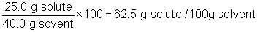
You can also solve this problem by using ratios. The equation above is a modified form of a ratio. If you solve this problem using ratios, it would look like this:
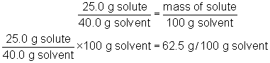
You may choose the method that you like best.
Example 2. If 30.1 g of a solute can dissolve can dissolve in 350.0 mL of water at a certain temperature, what is the solubility of the substance in g/100g water?
Solution.
We are given mL of water, which is volume. We need to convert the volume of water to mass of water. We will always assume the density of water is 1g/mL, unless indicated otherwise. So the mass of water is 350.0 g.
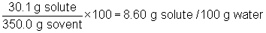
or by using ratios
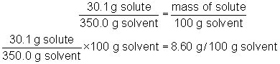

The Solubility Curve

As we saw in the previous pages, solubility is temperature dependent. We can find the solubility of a substance at various temperatures and plot this data on a graph. The result is what is known as a solubility curve. The diagram below shows an example of a solubility curve for potassium nitrate.
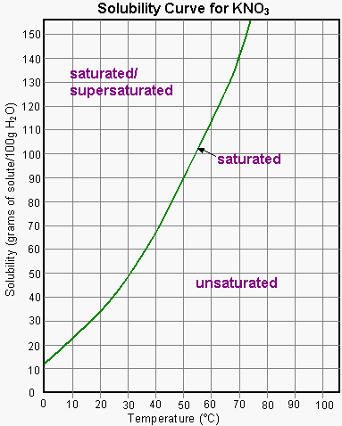
Each point on the curve represents a saturated solution of potassium nitrate. The area below the curve represents quantities that produce an unsaturated solution at that temperature. The points above the curve indicate either a supersaturated solution or a saturated solution with some remaining undissolved solute.

Example 3. What is the solubility of potassium nitrate at 20°C?
Solution.
Start at 20°C and move up to the curve, then across to the solubility axis.
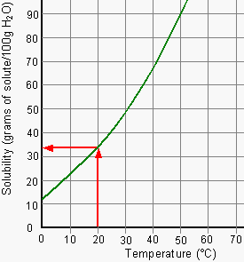
The solubility of potassium nitrate at 20°C is about 33 g/100 g water.

Example 4. At what temperature is the solubility of potassium nitrate 20 g/25 g water?
Solution.
The units in the graph are g/100 g water. We are given 20 g/25 g water. We need to convert the given amount into g/100g water.
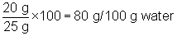
or using ratios
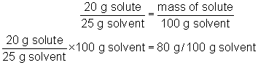
Start at 80 g on the y-axis, move across to the curve, then down to the temperature axis.
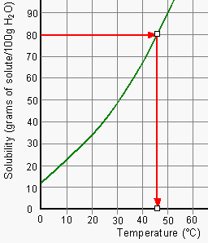
The solubility of potassium nitrate is 20 g/25 g water at about 46°C.

Example 5. Is a solution of 50 g of potassium nitrate in 100 g of water a saturated, unsaturated or supersaturated at 50°C?
Solution.
The y-axis indicates that the units of solubility are g/100g water. Using the graph, is 50g/100g water a saturated solution? Start on the x-axis at 50°C and move up to the 50 g mark.
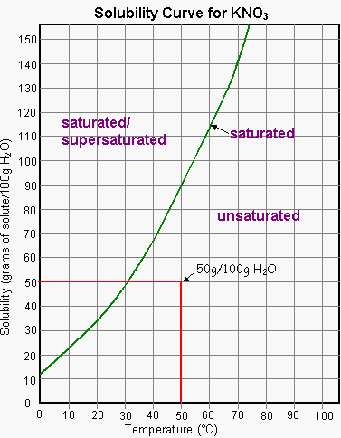
Do you cross the solubility curve? No
The solution is unsaturated, since 90 g of KNO₃ can dissolve in 100 g of water at 50°C.

Example 6. A 75 mL of a saturated solution of KNO₃ at 70°C is cooled to 40°C. How much solid precipitates from the solution?
Solution.
From the graph, a saturated solution of KNO₃ at 70°C is 140 g/100 g water.
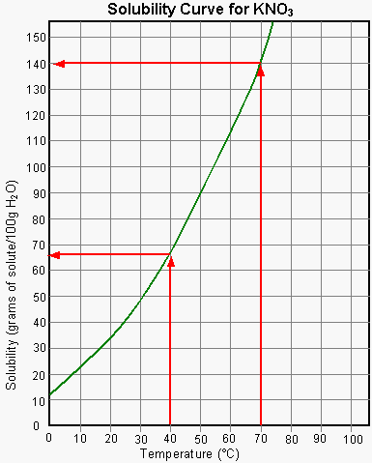
We only have 75 mL of water. Assuming the density of water is 1 g/mL, the mass of water is 75 g. We must convert the solubility read from the graph into g/75 g water. We do this for both temperatures given in the question: At 70°C:
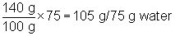
At 70°C, 105 g of solute will dissolve.
If we cool the solution, the solubility of the solid will decrease. Reading the graph at 40°C, we see the solubility is now about 66 g/100g water. We must convert this value top g/75 g water.
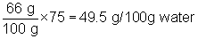
At 40°C, only 49.5 g of solute will dissolve
If only 49.5 g remains in solution and we started with 105 g, then the amount that comes out for solution is
105 g – 49.5 g = 55.5 g
55g will precipitate out of solution upon cooling.

Example 7. What volume of water is required to dissolve 240 g of of KNO₃ at 60°C?
Solution.
From the graph,
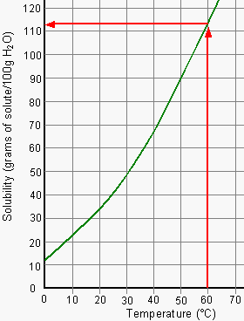
at 60°C the solubility of KNO₃ is 113 g/100 g water.
Using ratios,
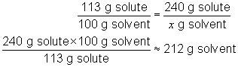
About 212 g of water or 212 mL of water is needed.

