Practice
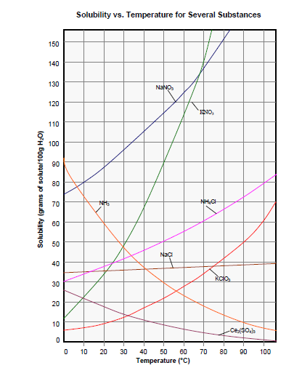

Use the solubility curves above to answer the following questions

Assume the density of water is 1.00 g/mL
- Calculate the solubility of each of the following in g of solute/100 g of water.
  - 0.62 g dissolves in 15 mL of water.
  - 75.0 g dissolves in 350. mL of water.
  - 0.250 kg dissolves in 1.2 L.
  - 24.0 g dissolves in 280 g of water.

- Determine the solubility of the following in g solute/L water.
  - 260 g of a solid dissolves in 1500 mL of water.
  - 0.160 kg of a solid dissolves in 225 g of water.

- At what temperature is the solubility of the substance specified? (All in water)
  - NH₄Cl 60 g/100g
  - KNO₃ 120 g/100 g
  - NaNO₃ 1200 g/L
  - KClO₃ 100 g/500 g

- What is the solubility, in g/ 100g water, of the following at the specified temperature?
  - NaNO₃ at 40°C
  - Ce₂(SO₄)₃ at 25°C
  - NH₃ at 30°C
  - NH₄Cl at 5°C

- How much more NH₄Cl can you dissolve in a Litre of water at 60°C than at 20°C?

- If you prepared a saturated solution of NaNO₃ at 80°C then cooled it to 30°C, what would happen? Be specific.

- At which temperature do NaNO₃ and KNO₃ have the same solubility? NaCl and NH₃?

- How much water is needed to dissolve 65.0 g of NaNO₃ at 35°C?

- A saturated solution of KNO₃ in 200. g of water at 50°C is cooled to 20°C. How much
KNO₃ will settle out?

- What temperature is necessary to dissolve twice as much KNO₃ as can be dissolved at 30°C?

- If the solubility of a solid in water is 118 g/L, how much water would you need to dissolve a piece of the same solid with a mass of 45.0 g?

- If 18.0 g of KNO₃ are dissolved in 15.0 mL of water at 100°C, at what temperature will the solid begin to settle out?

- If 40.0 g of KNO₃ is added to 50.0 mL of water at 40°C will it all dissolve? If not, how much would be left over? If you raised the temperature to 45°C, will it all dissolve? Give evidence

- What temperature is necessary to just dissolve 150 g of KClO₃ in 200. mL of water?

- If 142 g of NH₄Cl are dissolved in 350 mL of water at 55°C, is the solution saturated?

Answers

  - 4.13 g/100 g H₂O
  - 21.4 g/100 g H₂O
  - 20.8 g/100 g H₂O
  - 8.57 g/100 g H₂O

  - 173 g/L H₂O
  - 711 g/L H₂O

  - 68°C
  - 63°C
  - 56°C
  - 46°C

  - 106 g/100 g
  - 16 g/100 g
  - 48 g/100 g
  - 32 g/100 g

- You can dissolve 17g/100g more

- 55 g of NaNO3 will settle out for every 100 g of water.

- 68°C, 41°C

- 65 g water

- 112 g KNO3 will settle out

- 53°C

- 0.38 L or 380 mL are needed to dissolve 45 g of solute

- KNO3 will begin settling out at 62°C.

- At 40°C solubility of KNO3 is about 68 g/100 g water. Not all the solute will dissolve. 80 g – 68 g = 12 g 12 g will not dissolve at 40°C. At 45°C, the solubility is about 79 g/100 g water. Not all the solute will dissolve.

- 95°C

- The solution is unsaturated.

