Mixing Solutions With the Same Solute

When we mix two or more solutions having the same solute, but different concentrations, the concentration of the solute in the final mixture changes. Since concentration is the number of moles of solute in a Litre of solution, the final concentration of the mixture will be the total number of moles per Litre of solution, or
Since the number of moles, n, of solute in a solution can be calculated by
n = C×V
We can substitute this equation for n's in the first equation
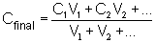
Where: | C₁ is the concentration of solution 1, in mol/L
 | V₁ is the volume of solution 1, in L
 | C₂ is the concentration of solution 1, in mol/L
 | V₂ is the volume of solution 1, in L

Example 5. 450. mL of a 0.150 mol/L NaCl solution is mixed with 125 mL of a 0.220 mol/L NaCl solution. What is the new NaCl concentration?
Solution.
We know:
  - The concentration of solution 1, C₁, is 0.150 mol/L
  - The volume of solution 1, V₁, is 450. mL = 0.450 L
  - The concentration of solution 2, C₂, is 0.220 mol/L
  - The volume of solution 2, V₂, is 125 mL = 0.125 L
We have 2 solutions with the same solute, so we use the equation above and substitute the given values.
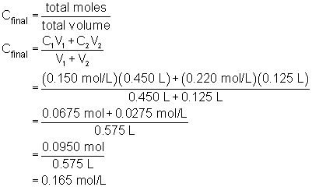
Notice that the final concentration is between the concentrations of the two original solutions. This is one quick check to make sure you have calculated correctly.

