Millikan Oil Drop Experiment Problem:

Question:
An oil drop, whose mass is found to be 4.95 x 10⁻¹⁵ kg is balanced between two large horizontal plates with the upper plate positive. The electric field strength between the plates is E = 5.10 x 10⁴ N/C. What is the charge on the oil drop, both in coulombs and in elementary charges, and is it an excess or deficit in electrons?

Solution:
The charge on the oil droplet is
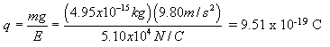.
The number of elementary charges is
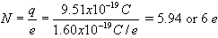
The upper plate is positive, so for the electrical force to be up, the oil droplet must be negatively charged. Therefore, it must have gained 6 electrons. There is an excess of electrons.

