Magnetic Poles

The effects of magnetism have been known for centuries. Even before 600 B.C., the Greeks had discovered that lodestone, a type of ore containing iron oxide, was able to exert forces of attraction on small iron objects. Also, when pivoted in a horizontal plane and allowed to rotate freely, a needle-shaped piece of lodestone would always come to rest in a north-south position, a fact that led to its widespread use in navigation. Since this type of iron ore was first found near a region in Asia Minor called Magnesia, its effects became known as magnetism.
Nowadays, lodestone is rarely used for its magnetic properties. Artificial magnets made from various alloys of iron, nickel, cobalt, and gadolinium have replaced it. When a bar magnet is dipped in iron filings, the filings are attracted to it and accumulate most noticeably around regions at each end of the magnet, called poles. When a bar magnet is allowed to rotate freely, the pole that tends to seek the northerly direction is called the north magnetic pole, or simply the N-pole. The opposite end is called the south magnetic pole, or the S-pole.

Magnets can exert forces on each other. By observing how magnets interact with each other, we can state the Law of Magnetic Poles as opposite magnetic poles attract, and similar magnetic poles repel. Another way of saying this is that like poles repel each other, and unlike poles attract. This behaviour is similar to that of like and unlike electric charges. However, it is important to keep one important difference in mind. It is possible to separate positive from negative charges and produce isolated charges of either kind. In contrast, no one has found a magnetic monopole (an isolated north or south pole). Any attempt to separate north and south poles by cutting a bar magnet in half fails, because each piece becomes a smaller magnet with its own north and south poles.

Magnetic Field Line Determination using a Compass or Iron Filings

Magnetic forces act at a distance, just like gravitational and electrical forces do. Magnets create magnetic fields just as masses create gravitational fields and electric charges create electric fields. A magnetic field can be detected by its effect on a small compass (magnetized needle). The magnetic field is depicted visually by drawing magnetic field lines that show the direction in which the north pole of the test compass points. An arrow, the head of the arrow being the north pole, symbolizes the compass needle. The diagram shows how compasses can be used to map out the magnetic field in the space surrounding the bar magnet. Since like poles repel and unlike attract, the needle of each compass becomes aligned relative to the bar magnet in the manner shown in the picture. The compass needle provides a visual picture of the magnetic field that the bar magnet creates in the surrounding space.
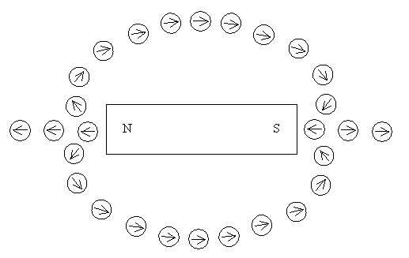

Another way to create a visual image of the magnetic field lines in a plane is to sprinkle finely ground iron filings on a piece of paper that covers the magnet. Iron filings behave like tiny compasses and align themselves along the magnetic field lines.

Magnetic Field Line Pattern for a Bar Magnet

If we now remove the compasses from the diagram in the previous section, and draw in the magnetic field lines, the diagram would look as shown below. Additional field lines have been added to give a more complete picture.

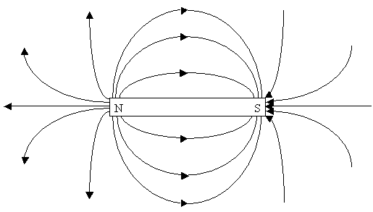
Notice that the lines appear to originate from the north pole and to end at the south pole. The lines do not start or stop in mid space. As is the case with electric field lines, the direction of the magnetic field at any point is tangent to the magnetic field line at any point. Furthermore, the strength of the magnetic field is proportional to the number of field lines per unit area that passes through a surface oriented perpendicular to the lines. Thus, the magnetic field is stronger in regions where the field lines are relatively close together and weaker where they are relatively far apart. For instance, the lines are closer together near the north and south poles, reflecting the fact that the strength of the magnetic field is greatest in these regions. Away from the poles, the magnetic field becomes weaker. Compare the magnetic field line pattern above with the electric field line pattern below and notice how similar they are.
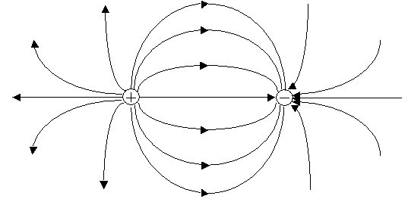

Magnetic Field and the Horseshoe Magnet

In a horseshoe magnet the magnetic field lines are concentrated in the immediate region between the poles. Note how the magnetic field lines for the horseshoe magnet compare to those of the bar magnet.
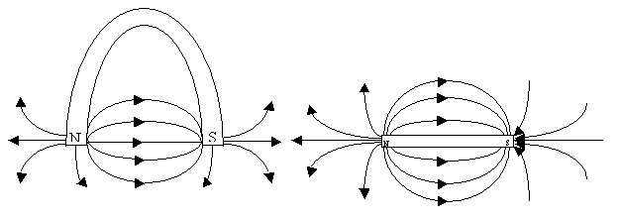
The magnetic field lines between the magnets repel when two magnets are placed near each other so that like poles face each other. The diagram below shows two bar magnets with south poles facing each other.
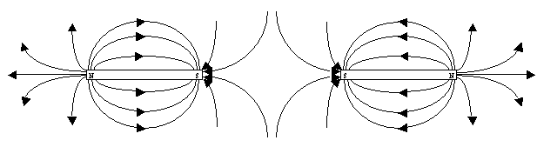
The following diagram shows a possible field line pattern for opposite poles of bar magnets facing each other.
