The Direction of the Force on a Current Carrying Wire

In the previous lesson we saw that an electric current exerts a force on a magnet such as a compass needle. In our study of dynamics, we learned by Newton’s Third Law that if one object exerts a force on a second object, then the second object must exert an equal and opposite force on the first. So we might expect that a magnet exerts a force on a current carrying wire. This is indeed the case and this was also discovered by Oersted.
The diagram below shows a horseshoe magnet and its magnetic field. A current carrying wire is placed between the poles of the magnet so that the current is perpendicular to the field. The symbol on the left indicates that the electric current is perpendicular to this plane and pointing into the plane.
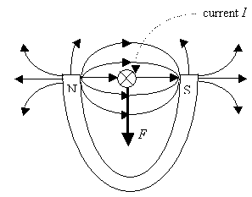
When the current flows through this wire, a force is exerted on the wire. But this force is not toward one or the other poles of the magnet. Instead, the force is directed at right angles to the magnetic field direction. In this case the wire will be forced downwards. If the current is reversed in direction, the force will be in the opposite direction. So in the above situation, if the current was coming out of the plane instead of into the plane, the force on the wire would be up. Thus it is found that the direction of the force, F is perpendicular to the direction of the current, I and also perpendicular to the direction of the magnetic field, B. This description however does not completely describe the direction since the force could be either up or down and still be perpendicular to both the current and the magnetic field. Experimentally the direction of the force is given by another right hand rule. This right hand rule can be described by following three steps.
- First you orient your right hand so that your thumb points in the direction of the conventional current. For the example above, point your thumb into the plane.
- From this position, bend your fingers so that they point in the direction of the magnetic field lines. In the above case, this would require you to rotate your hand so that your fingers point towards the south pole.
- When your hand is oriented in this way, your palm opens in the direction of the force on the wire. So for the example this would have been down.
The Magnitude of the Force on a Current Carrying Wire

Experiments can be done to study the factors affecting the magnitude of the force on a current carrying conductor in a magnetic field. It has been found that the magnitude of the force is directly proportional to
- the strength of the magnetic field: F B
- the length of the conductor in the magnetic field: F L
- the current flowing through the conductor: F I
If we assume that the conductor passes through the magnetic field at right angles to it, then the magnitude of the force on the wire is F = BIL. Note that the standard unit of electrical current is the ampere (A). It is measured with a device called an ammeter.
We can rearrange this equation and solve for the magnetic field strength: 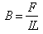. The standard metric unit of magnetic field strength is the tesla (T). A unit of 1 tesla (T) is defined to be the magnetic field strength when a conductor with a current of 1 ampere (A) and a length of 1 metre (m) at an angle of 90º to the magnetic field, experiences a force of 1 newton (N).
Thus the magnitude of the force on a current carrying conductor in a magnetic field is
F = BIL
where
- F is the force on the conductor in newtons
- B is the magnitude of the magnetic field strength in teslas
- I is the current in the conductor in amperes
- L is the length of the conductor in the magnetic field in metres
If the current carrying wire crosses the magnetic field at some angle , then the force on the current carrying wire can be written as F = BIL sin. If the current is parallel to the magnetic field, then there will be no force on the wire at all.

Determination of Magnetic Field Strength by Measuring Force on a Wire

One of the ways to determine the magnetic field strength inside a magnet is to use a device that can measure the force on a current carrying wire. A rectangular loop of wire hangs vertically as shown in the figure below. A magnetic field B is directed horizontally, perpendicular to the wire and points out of the page at all points represented by the symbol showing a dot inside a circle. Let us assume that the magnetic field B is uniform along the horizontal portion of the wire ab (length L = 10.0 cm) which is near the centre of a large magnet producing the field. The top portion of the wire loop is free of the field. The loop hangs from a balance which measures a downward force F = 3.48 x 10⁻² N when the wire carries a current I = 0.245 A. We can now determine the magnetic field strength at the centre of the magnet.
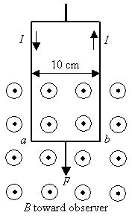
The magnetic forces on the two vertical sections of the wire loop are in equal and opposite directions and so add up to zero. Hence, the net magnetic force on the loop is that on the horizontal section ab whose length is L = 0.100 m. The magnetic field strength must be
