Exercise – Reaction Mechanisms

1. Given the following reaction mechanism:
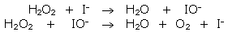
a) Write the balanced net reaction.
b) Identify the reaction intermediate(s).
c) Identify the catalyst(s).
2. Examine the following reaction mechanism:
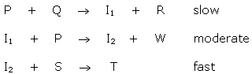
a) Write out the net reaction.
b) Identify the overall rate of the net reaction.
c) Increasing [ P ] , increases the rate of the net reaction.
Increasing [ Q ] , increases the rate of the net reaction.
Increasing [ S ] , has no effect of the rate.
Explain why this is possible.
3. Write the net reaction for the mechanism.
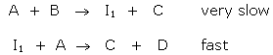
4. A proposed mechanism for the preparation of the poisonous liquid nitrobenzene (C₆H₆NO₂) is
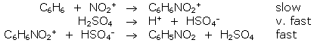
a) What is the RDS? Why?
b) What is the net reaction?
c) Without H₂SO₄ this is a very slow reaction. Explain.

Answer Key
1.
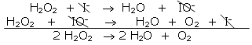
intermediate: IO–
catalyst: I–
2.
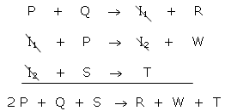
b) Since the rate determining step is slow, the entire rate is slow.
c) Increasing [ P ] , increases the rate of the net reaction.
Increasing [ Q ] , increases the rate of the net reaction.
Increasing [ S ] , has no effect of the rate.
This occurs because both P and Q are present in the rate determining step, but S is not. Only reactants in the rate determining step will significantly affect the rate of the reaction.
3. 2 A + B → 2 C + D
4.
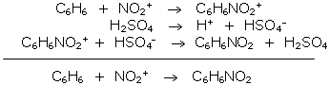
a) The RDS is C₆H₆ + NO₂⁺ → C₆H₆NO₂⁺ because it is the slowest step.
b) C₆H₆ + NO₂⁺→ C₆H₆NO₂
c) H₂SO₄ is introduced in step 2 and is unchanged at the end of the reaction. H₂SO₄ is most likely a catalyst since it speeds up the reaction and is unchanged at the end of the reaction.
d) Step 1 is slowest, therefore it has the largest activation energy. Step 2 is the fastest, so it should have the smallest activation energy. Step 3 is fast, so it should have a small activation energy.

