Exercise – Factors Affecting Reaction Rate
- In general, what effect does an increase in the concentration of the reactants have on the rate of the reaction? (explain using the collision theory)

- How do changes each of the following factors affect the rate of a chemical reaction? Use diagrams to clarify your explanations.
- Temperature
- particle size
- pressure
3. Which equation of the following pairs of equations would occur the fastest at under the same conditions. Explain your answers.
- i) Zn²⁺(aq) + S^{2–}(aq) → ZnS(s)
ii) Zn(s) + S(s) → ZnS(s)
- i) 2 H₂O₂(aq) → 2 H₂O(l) + O₂(l)
ii) Cu(s) + 2 AgNO₃(aq) → 2 Ag⁺(aq) + Cu(NO₃)₂(aq)
- i) Pb(NO₃)₂(aq) + 2 KI(aq) → PbI₂(aq) + 2 KNO₃(aq)
ii) C₃H₈(g) + 5 O₂(g) → 3 CO₂(g) + 4 H₂O(g)
- i) 2 Fe(s) + 3 O₂(g) → 2 Fe₂O₃(s)
ii) 2 NO(g) + O₂(g) → 2 NO₂(g)

Answer Key
1.
- Increasing the concentration of reactants, increases the number of particles in the container.
- An increase in the total number of particles increases the number of particles with kinetic energy greater than or equal to activation energy.
- More particles with activation energy means more frequent effective collisions.
- More effective collisions results in an increased reaction rate.
- Increasing the number of particles in a container reduces the spaces between the particles.
- Smaller spaces between the particles results in a greater probability of collisions occurring therefore increased frequency of collisions.
2. a)
- Increasing temperature, increases the rate of most reactions
- Decreasing the temperature will decrease the rate.
- Increasing the temperature, increases the kinetic energy of all the particles, shifting the kinetic energy distribution curve to the right(T3 in the figure below).
- More particles have activation energy, therefore increased reaction rate
- Decreasing temperature, decreases kinetic energy of all particles (T1 in figure below)
- Less particles with activation energy, therefore lower rate.
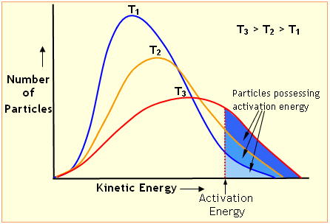
2. b)
- Changing particle size is only effective for heterogeneous and solid reactants.
- Grinding the reactants increases number of reactant particles in contact.
- Increased particles in contact, increases frequency of collisions and reaction rate.

c)
- Pressure changes only affect gaseous reactants.
- Increasing pressure reduces space between particles, increasing probability of collisions.
- Increased probability of collisions, increases frequency and rate.
- Decreasing pressure, increases spaces between particles.
- Decreasing pressure decreases frequency of collisions and, therefore, rate.
3.
- The reaction Zn²⁺(aq) + S^{2–}(aq) → ZnS(s) is faster, since the reactants are all aqueous. The reactants in reaction (ii) are solids. Solid reactants react slowest.
- The reaction Cu(s) + 2 AgNO₃(aq) → 2 Ag⁺(aq) + Cu(NO₃)₂(aq) is the fastest. This reaction involves the transfer of electrons from Cu to Ag+, while the other involves the breaking of covalent bonds.
- The reaction Pb(NO₃)₂(aq) + 2 KI(aq) → PbI₂(aq) + 2 KNO₃(aq) is faster. Reactions with aqueous reactants are almost instantaneous. The other reaction involved the breaking of many covalent bonds.
- 2 NO(g) + O₂(g) → 2 NO₂(g) is a homogeneous reaction of gaseous reactants, while the reaction 2 Fe(s) + 3 O₂(g) → 2 Fe₂O₃(s) is bewteen heterogeneous reactants. (Consider how slowly iron rusts)

