Exercise
1. Given the following reaction coordinate diagram
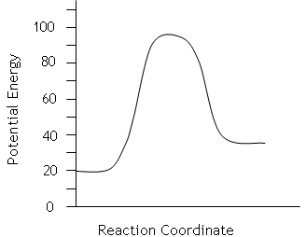
a) What is the activation energy of the reaction shown by the diagram?
b) What is the enthalpy change for this reaction?
c) Is this reaction endothermic or exothermic?
2. Given the following reaction coordinate diagram
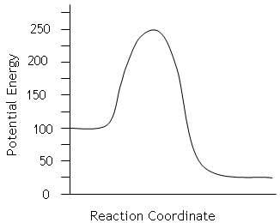
a) What is the activation energy of the reaction in the diagram to the left?
b) What is the enthalpy change for this reaction?
c) Is this reaction endothermic or exothermic?
d) What would be the activation energy of the reverse reaction?

3. Given the following reaction coordinate diagram
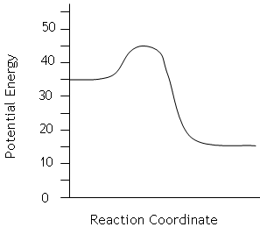
a) What is the activation energy of the diagram to the left?
b) What is the enthalpy change for this reaction?
c) Is this reaction endothermic or exothermic?
d) What would be the activation energy of the reverse reaction?
- What is the activated complex or transition state and how is it related to reaction rates? Label the position of the activated complex in each of the diagrams above.
- Does every collision between reactant particles produce a reaction? Explain.
- Explain why the enthalpy change for an exothermic reaction is negative, even though the container gets warmer.

Answer Key
1.
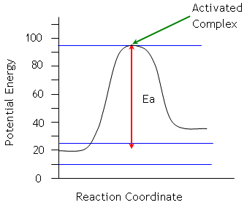
a) Ea = 95 kJ – 20 kJ = 75 kJ
b) ΔH = Hproduct – Hreactant = 35 kJ – 20kJ = 15 kJ
c) Since ΔH is positive the reaction is endothermic.
2.
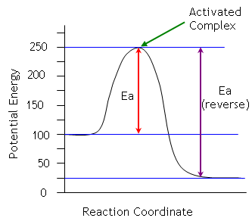
a) Ea = 250 kJ – 100 kJ = 150 kJ
b) ΔH = Hproduct – Hreactant = 25 kJ – 100 kJ = –75 kJ
c) Since ΔH is negative the reaction is exothermic.
d) For the reverse reaction, products now become the reactants.
Therefore, Ea = 250 kJ – 25 kJ = 225 kJ
3.
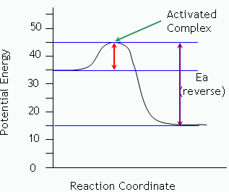
a) Ea = 45 kJ – 35 kJ = 10 kJ
b) ΔH = Hproduct – Hreactant = 15 kJ – 35 kJ = –20 kJ
c) Since ΔH is negative the reaction is exothermic.
d) Ea = 45 kJ – 15 kJ= 30 kJ
- The activated complex is a short-lived combination of atoms formed at the top of a potential energy diagram from reactants to product. See above for labels.

- Not every collision produces a reaction. Collisions must have enough energy and correct orientation for a reaction to occur.

- Exothermic reactions release energy. This means energy is lost form the system. Since energy is lost, the system has less energy than it began with (enthalpy of products less than enthalpy of reactants). This produces a negative value.

