Charged Parallel Plates and Force

We have already studied the electric field line pattern between two charged parallel plates. The electric field lines point away from the positive plate towards the negative plate. There is a slight bulge at each edge of the plates.
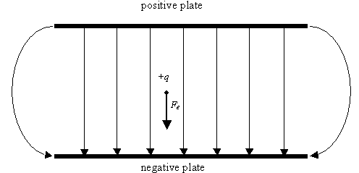
In the region between the plates, the electric field lines are parallel and evenly spaced. This indicates that the electric field has the same magnitude and direction at all points.
If a positive point charge is placed between the plates, the net force on the charge will be in the same direction as the electric field lines. A negative point charge will move in a direction opposite the electric field line direction. The amount of the electric force on the charged particle can be determined by F_{e} = qE.

If the electric force is the only force acting on the charged object, then the acceleration of the object can be determined from Newton’s second law: F = ma.
For example, if the electric field strength between the charged plates is 10.0 N/C, and the object has a charge of q =+ 2.00 C and a mass of m => 4.00 x 10⁻⁴ kg, then the acceleration of the particle is

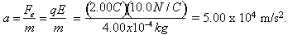

The direction of the acceleration is in the same direction as the force. For the diagram above, the charge would accelerate in the down direction.

If the charged plates are oriented in an up and down direction as shown above, then the particle also experiences a force of gravity F_{g} acting downwards. The magnitude of this force is
F_{g} = mg = 3.92 x 10⁻³ N.
Since both the electrical force and the force of gravity are acting downwards, the net force is
F_{net} = F_{e} + F_{g} = qE + mg = (2.00C)(10.0N/C) + (4.00x10⁻⁴)(9.8N/kg) = 20.0 N
As you can see, the effect of the gravitational force is negligible compared to the electric force.

Charged Parallel Plates and Kinematics

In our study of kinematics, we applied three equations to the motion of objects.
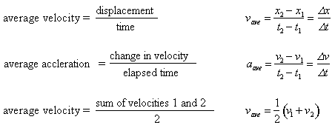
In the previous example, we saw that a charge of +2.00 C accelerated downwards at a rate of
5.00 x 10⁴ m/s² downwards, or -5.00 x 10⁴ m/s².

If the particle accelerates downwards for 6.00 s (6.00 x 10⁻⁶ s), the change in velocity is
v = at = (-5.00x10⁴ m/s²)(6.00x10⁻⁶) = -0.300 m/s
If the initial velocity of the charged object is zero, then after 6.00 ms, the new velocity of the particle is 0.300 m/s and the average velocity is
v_{ave} = (0.00m/s + -0.300m/s) = -0.150 m/s.
The downward displacement of the charged particle is
x = v_{ave}t = (-0.150m/s)(6.00x10⁻⁶) = = -9.00 x 10⁻⁷ m.

