Calculating Electric Field and Electric Force

Introduction
In the previous lesson we discussed how to draw electric field lines. In this lesson we discuss how to calculate the total electric field in a region where more than one electric field exists at a given point. We will then be able to calculate magnitude and direction of the total force exerted on a charge at a point where one or more electric fields exist. Since electric field has magnitude and direction, we must apply the rules of vector addition to add together two or more electric field vectors.

Electric Field
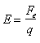
We can defined the value electric field strength, E, to be the ratio of the electric force, F_{e}, to the charge, q, experiencing the force. (Similar to formula we have for gravitational fields: $g=\frac{F_{g}}{m}$)

If the electric field strength is known, then to calculate the electric force, F_{e}, acting on a charge, q, in an electric field, E, we use F_{e} = qE
The electric field, E, and the electric force, F_{e}, are both vectors. When determining the electric force, both the magnitude (size), and the direction of the force should be stated. The electric field line pattern for a positive point charge and a negative point charge was discussed earlier.
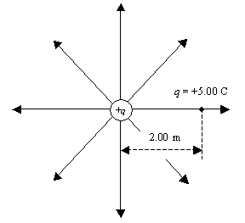 | 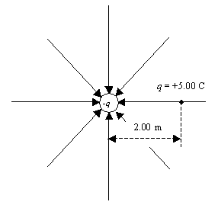
A test charge of +5.00 C is placed a distance of 2.00 m to the right of the point charge +q. The strength of the electric field produced by this charge is 10.0 N/C at the location of the charge q.  The electric force on the charge q is  Fe = qE = (+5.00C)(10.0N/C) = +50.0N  The charge test charge, q, and the point charge producing the electric field, +q, are both positive, so that charges repel each other. The direction of the force is to the right (or east). | A test charge of +5.00 C is placed a distance of 2.00 m to the right of the point charge -q. The strength of the electric field produced by this charge is 10.0 N/C at the location of the charge q.  The electric force on the charge q is  F_{e} = qE = (+5.00C)(10.0N/C) = +50.0N  The charge test charge, -q, and the point charge producing the electric field, +q, are opposite in charge, so that charges attract each other. The direction of the force is to the left (or west).

Electric Field and Force in One Dimension

In our work in dynamics, we reviewed how to add vectors. If there exists at a place in space, electric fields caused by more than one source, then the fields will add together like vectors since electric field is a vector.
In the situation below, there are two charges. The positive charge, q₁, on the left creates an electric field, E₁, of 10.0 N/C to the right at position P. The positive charge on the right, q₂, creates and electric field, E₂, of 15.0 N/C to the left and position P.
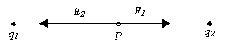
The total electric field at position P is E_{T} = E₁ + E₂ = 10.0 N/C + (-15.0 N/C) = -5.0 N/C or
5.0 N/C west.
If a charge of 2.0 C is placed at position P, then the force on this charge is
F = qE_{T} = (2.0 C)(5.0 N/C) = 10. N. The direction of this force is in the same direction as the electric field vector, that is west.
Similarly, if a charge of -2.0 C is placed at P, then the force on this charge would be 10. N. But the direction of the force would be opposite to the direction of the electric field which is east.

Electric Field and Force in Two Dimensions
In the next situation, the two electric fields are at right angles relative to each other. The positive charge, q₁, creates and electric field of 10.0 N/C north while the charge, q₂, creates and electric field of 15.0 N/C east.
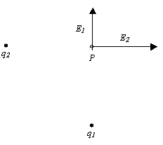

In adding together the two electric field vectors. We attach them head to tail.

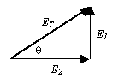
The magnitude of the total electric field vector is
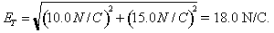
The direction of this vector is
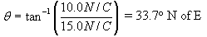
If a charge of 2.0 C is placed at position P, then the force on this charge is
F = qE_{T} = (2.0 C)(18.0 N/C) = 36. N. The direction of this force is in the same direction as the electric field vector, that is 33.7º N of E.
Similarly, if a charge of -2.0 C is placed at P, then the force on this charge would be 36. N. But the direction of the force would be opposite to the direction of the electric field which is 33.7º S of W.

