Air Resistance and Terminal Velocity
If a billiard ball and a styrofoam ball are dropped simultaneously, the styrofoam ball will quickly lag behind the billiard ball. Air resistance creates this difference. As the balls fall and their velocity increases, the air resistance also increases. The net force causing the acceleration of the balls is made up of two components, the force of gravity, F_{g}, downward and the air resistance or drag force, F_{d}, upward. As long as F_{g} > F_{d}, then F_{net} > 0, and the downward acceleration will occur. But as the force of air resistance increases, the magnitude of the net force will decrease, thus decreasing the acceleration. Eventually, the force of air resistance will equal the force of gravity, F_{a} = F_{d}, the net force on the object is zero, and the object is no longer accelerating. We say that the object has reached terminal velocity. The value for the terminal velocity will vary. It is quite a bit slower for the styrofoam ball than it is for the billiard ball.
Diagram A  Free fall begins.  No air resistance. | Diagram B  Object falling in air.  Air resistance increases. | Diagram C  Terminal velocity.  Air resistance equals gravitational force.
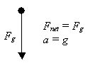 | 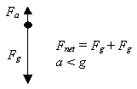 | 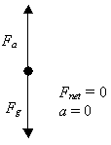
Although the surface of the styrofoam ball is different from that of the billiard ball, this is not the major factor affecting the terminal velocity of the ball. In fact, at slow speeds, the air resistance on each ball will be similar. Their masses are vastly different so the net downward force on the billiard ball is much greater than on the styrofoam ball. The result is that the billiard ball will have a higher terminal velocity than the styrofoam ball and it will take more time for the billiard ball to reach its terminal velocity. The diagram below shows both balls shortly after they have begun their fall.
When a parachutist jumps from an airplane, terminal velocity will also be reached. The graph below shows possible velocities at various times.
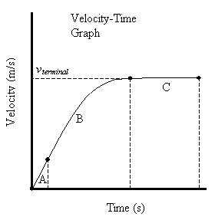
In section A, air resistance is negligible making F_{net} = F_{g}. This results in a constant slope on the v-t graph.
In section B, air resistance increases, resulting in a decreasing net force and a decreasing rate of acceleration. Thus the graph is curved in this section.
In section C, the air resistance has increased to the point where F_{d} = F_{g} and the net force on the parachutist is zero. No acceleration occurs so the slope of the v-t graph in this section is zero. The parachutist falls at a constant velocity and this is the terminal velocity.
When the parachutist is falling at the terminal velocity (about 200 km/h), the velocity can be changed by increasing or decreasing the surface area. This is done by changing the position of the arms and legs. When the parachute opens, the air resistance suddenly increases and F_{d} > F_{g}. The parachutist is then decelerated to a slower terminal velocity (typically 3.0 to 4.3 m/s). At this point F_{d} = F_{g} again.

Example:
A 1.0 kg ball is allowed to fall through the air. When its downward velocity is –10.3 m/s, the force of air resistance is 3.0 N upwards. What must be the net force on the ball at this moment and what must be the acceleration of the ball?

Answer:
The gravitational force is F_{g} = mg = (1.0 kg)(-9.8 N/kg) = -9.8 N.
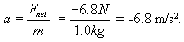
The net force must be F_{net} = F_{d} + F_{g} = 3.0 N - 9.8 N = -6.8 N.
The acceleration of the ball at this moment is

