Collision Theory and Mechanisms
Consider the reaction:
2 NO(g) + O₂(g) → 2 NO₂(g)
According to the collision theory, for this reaction to occur in one step, 3 particles must collide: two NO molecules and one O₂. These particles must collide at exactly the same time with the correct orientation and enough energy.
Successful three particle collisions are quite rare. We can think of a three particle collision in terms of a pool shot. Striking the cue ball to create a collision which puts one ball in a pocket is difficult. Making a "combination" shot, striking two balls with enough energy and the correct angles to sink both balls with one shot is much more difficult, and rarely attempted.
In order for chemical reactions to occur more quickly, reactions tend to take place in steps, with each step involving a collision between two particles, or bimolecular. The chance of a two particle collision being successful is much greater than a collision between three or more particles.

Reaction Intermediates
Reactions which take place in one elementary step are called, appropriately, simple reactions or elementary reactions.
Reactions which take place in more than one step are called complex reactions.
The complex reaction:
2 NO(g) + O₂(g) → 2 NO₂(g)
does not take place in one elementary step, but actually takes place in two steps:
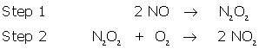
Compounds such as N₂O₂, products of one reaction that immediately become reactants in another reaction, are called reaction intermediates. All complex reactions contain at least one reaction intermediate. Reaction intermediates should not be confused with the activated complex. The activated complex is a temporary particle formed during a single step, while the reaction intermediate is a product of a step or reaction in a mechanism.

Net Reactions
The steps in which a reaction occurs is called that reaction's mechanism. The sum of the steps of a mechanism must equal the total or net equation.
For the reaction, NO₂ + CO → NO + CO₂ , the mechanism is as follows:
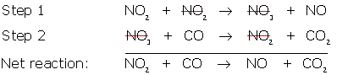
This mechanism agrees with the initial equation for this reaction, as the sum of the steps equals the original reaction. The NO₃ is the reaction intermediate, so it does not appear in the net reaction. Since NO₂ is found twice on the left and once on the right, we can cancel one of the NO₂'s just as we would adding equations in math.
Catalysts, as well as intermediates, do not appear in the overall reaction. CFC’s (chlorofluorocarbons) used as refrigerants and aerosol propellants have been responsible for the depletion of the ozone layer. In the stratosphere, the ultraviolet light causes a chlorine atom to become stripped from the CFC molecule.
CCl₂F₂ → CClF₂ + Cl
The decomposition of ozone using chlorine as a catalyst is illustrated in this mechanism:
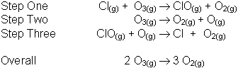
In the above example, the Cl(g) is a catalyst and the ClO is an intermediate. The catalyst can be identified in the mechanism by appearing as a reactant, THEN as a product in a following step.

Rate Determining Step
Not all steps in a mechanism have the same rate. The step with the slowest rate is called the rate determining step (RDS), since that step affects the rate of the reaction more than the others.
One way to illustrate the effect of the RDS is to imagine a sports team must take a trip to another city for a game. If half the team flies (fast step) and half the team take a bus (slow step), it does not matter how fast the flight is because the team cannot play until the bus arrives. The only way to get the whole team to the game faster is to speed up the bus trip. The bus trip is similar to the rate determining step because it has the largest effect on how fast the team reaches the city.
According to our last mechanism:
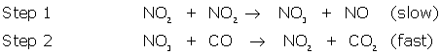
step 1 is the RDS because it is the slowest step.

Examples
Since the RDS affects the rate of the entire reaction the most, changes to the reactants in the other steps will have very little effect on the rate of the reaction.
Example 1. Given the following mechanism:
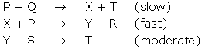
a) What is the net reaction?
b) What are the reaction intermediates?
c) Which is the rate determining step?
d) What would be the effect of increasing the concentration of P?
e) What would be the effect of decreasing the concentration of Q?
f) What would be the effect of increasing the concentration of S?
Solution:
a) by adding the three steps, eliminating the compounds common to both sides:
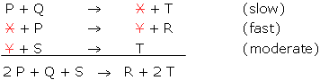
b) The reaction intermediates are X and Y, since they are products in one step and become reactants in the next. They also do not appear in the net equation
c) P + Q X + T(the slowest step)
d) If the concentration of P were increased, the rate of the reaction would increase, since P is present in the RDS.
e) If the concentration of Q were decreased, the rate of the reaction would decrease, since Q is present in the RDS.
f) If the concentration of S were increased, there would be NO change in the rate of the reaction, since S is NOT present in the RDS.

