The Nature of Reactants
Chemical reactions involve the breaking of bonds between atoms in the reactants and reforming bonds to make the products. The breaking of bonds requires energy and the forming of bonds releases energy. It makes sense then that the strength and number of bonds to be broken will affect the rate of a reaction.
1. The weaker the bonds to be broken the faster the reaction.
In general, covalent bonds are much stronger than ionic bonds. As a result, reactants that require the breaking of covalent bonds will be slower than those involving ionic bonds. Ionic compounds in aqueous solutions are already separated into ions, so these are usually very fast.
For example, between these reactions which would be the fastest?
H₂(g) + I₂(g) → 2HI(g)
Pb(NO₃)₂(aq) + 2NaI(aq) → PbI₂(s) + 2 NaNO₃(aq)
The first reaction requires the breaking of 2 covalent bonds (an H-H bond and an I-I bond). The second reaction is between ionic compounds in aqueous solutions. Ionic compounds in water dissociate into ions. This means there are no bonds to break in the second reaction and it will occur much faster.
2. When comparing reactions with similar bonds, the more bonds that must be broken the slower the reaction.
Think about dismantling an object if you want to fix it. The more parts that you need to separate, generally the longer it will take.
For example, if we compare the following two reactions
2 NO(g) + O₂(g) → 2 NO₂(g)
2 C₈H₁₈(g) + 25 O₂(g) → 16 CO₂(g) + 18 H₂O(g)
Both reactions involve breaking covalent bonds. The first reaction takes place in the atmosphere and is relatively quick because it only involves the breaking of one O-O bond and 2 N-O bonds.
The second reaction is the burning of octane (found in gasoline). This reaction is very slow at room temperature. If it weren’t slow, we would be able to store gasoline in the tanks of cars or in containers in our garages. This is a slow reaction because of the number of bonds that must be broken: 7 C-C bonds, 18 C-H bonds and 25 O-O bonds.
3. If the reactions have similar bonds and similar numbers of bonds, the state of the reactants is important.
Reactions with aqueous reactants tend to have the highest rates, followed by gases, then liquids and finally solids. Reactions between solids are usually slowest because the forces of attraction between the particles in a solid must be overcome before they can react. Reactions between aqueous reactants are often faster because there are fewer bonds to break. Reactions between gaseous reactants are also fairly quick because of the constant motion of the gas molecules and the greater likelihood of a collision occurring between the reactant particles.
Temperature Changes
According to the collision theory, the rate of a reaction is determined by the frequency or number of successful or effective collisions. An effective or successful collision is a collision between reactant particles with enough energy and the correct orientation. At any given temperature there is a fixed number of particles that possess enough energy to produce an effective collision, that is, activation energy.
The diagram below shows the kinetic energy distribution of a constant amount of a substance at various temperatures.
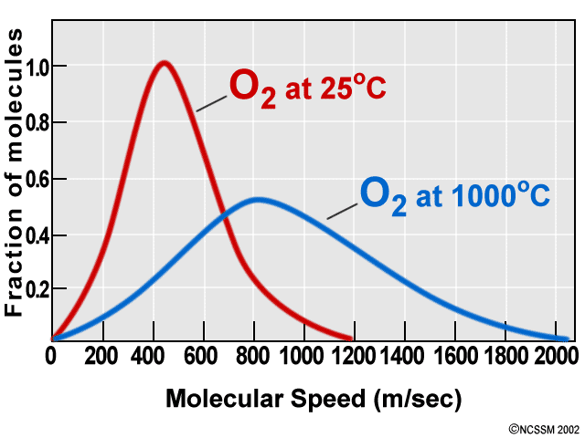
The area under the 2 curves remains constant, but the shape of the curves change as the temperature changes.
We can look at the effect of changing temperature and the number of particles with activation energy, that is, particles able to make a successful collision.
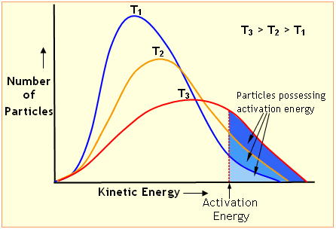
Notice how the number of particles possessing activation energy increases considerably with increased temperature. You should also notice that changing the temperature does NOT affect the activation energy. Remember that the activation energy for a reaction is based on many factors and is not affetcted by temperature.
As temperature increases, the average kinetic energy of the particles increases and the number of particles possessing activation energy increases. Since the number of particle with activation increases, the number of successful collisions will also increase.
Increasing kinetic energy also increases the speed of the particles. If the particles are moving faster, there will be more collisions.
If there are more successful collisions and the frequency of these collisions increase, then the reaction rate will increase.
Lowering the temperature reduces the average kinetic energy of the particles. This reduces the speed of the reactant particles and the number of reactant particles with activation energy. As a result, the frequency of effective collisions is decreased and the reaction rate decreases

Concentration Changes
Recall that concentration refers to the amount of reactant per unit volume. The units for concentration are mol/L.
Increasing the concentration of reactants increases the total number of particles in a container. If the number of particles in a container increases, so do the number of particles with activation energy. More particles with activation energy increases the frequency of effective collisions.
Increasing the number of particles in a container will also increase the chances of a collision. The diagram below illustrates the effect of doubling the concentration of just one of the reactants:
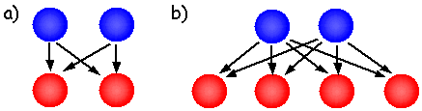
In (a), with two particles of each, there exists four possible collisions which could produce a reaction.
In (b), by doubling the number of red particles, the number of possible collisions increases to eight! This will increase collision frequency.
We can think of this in terms of collisions with cars as well. During rush hour, there are more accidents because there are more vehicles on the road at one time. The frequency of collisions increases because the "concentration" of vehicles is larger and the space between each vehicle is less, increasing chances of collision.

Catalysts
A catalyst is a substance that speeds up or initiates a reaction without itself being permanently changed.
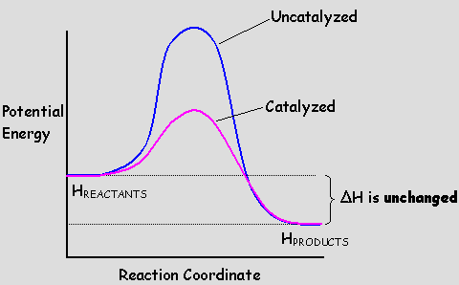
The reaction coordinate diagram, above, indicates that a catalyst speeds up a reaction by lowering the barrier, or activation energy, the reaction must overcome.
The catalyst does NOT affect the reaction products or the enthalpy change for the reaction. Both remain the same. Catalysts will only provide an easier path for the reaction to proceed.
Lowering the activation energy of a reaction, increases the number of particles with enough energy to produce an effective collision, as shown by the kinetic energy distribution below. More particles with activation energy means more frequent effective collisions and an increased reaction rate.
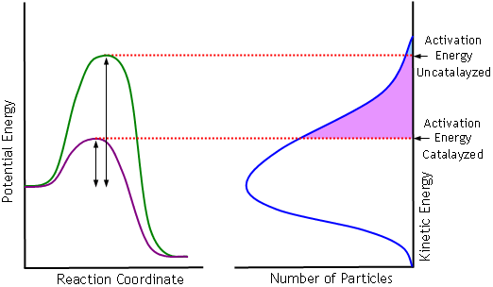
The shaded areas represent the number of particles with activation energy.
An inhibitor also affects reaction rates by stopping or slowing down reactions. It is the opposite of a catalyst.
Enzymes are known as biological catalysts. Most biological reactions, including digestion of food and clotting of blood, are controlled by enzymes.
Enzymes are capable of increasing the rate of biological reactions by over one million times! For example, in the body, simple sugars in food can be digested in a matter of minutes. How long does this take sitting on your counter-top?
Enzymes accomplish this by bringing the reactants, called substrates, together. The reactants bind to a certain part of the enzyme, called the active site. The reactants are then placed into a position which favours a reaction. The active sites can be very specific, binding to only one set of reactants, or they can catalyze several different types of reactions.
The reaction is a two-step mechanism:
Enzyme + Substrate → Enzyme-substrate complex
Enzyme-substrate complex → Enzyme + Product
The enzyme remains unchanged after the reaction and is able to catalyze another reaction. An enzyme can remain active for an indefinite number of reactions.
The control of biological reactions is accomplished by the enzymes. The body will either begin producing enzymes when the reaction is required, or the enzymes can be "activated" by the presence of certain chemicals or ions.

Pressure Changes
Changing the pressure on a system usually only affects the reaction rates of gaseous reactions.
Pressure is the force of particles upon the walls of their container. If the number of particles in a container increases without changing volume, the pressure increases.
There are 3 ways to change pressure:
- Add more product and/or reactant particles to the container.
- Increase or decrease the volume of the container
- Add an inert or unreactive gas.
If pressure is increased by adding more reactant particles, the concentration increases causing an increased rate. If the pressure is reduced by removing reactant, the rate decreases due to decreased concentration.
If you decrease the volume of a container without changing the number of particles in the container, as in figure c in the diagram below, the concentration of the reactants increases. The spaces between the particles decreases, increasing the chances of a collision. If the concentration of the reactants increases, the reaction rate increases.
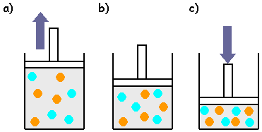
If you increase the volume of a container without changing the number of particles, as in figure a in the diagram above, the concentration of the reactants decreases. The spaces between the particles increases, decreasing the chances of a collision. Decreasing the concentration of reactants decreases the reaction rate.

Surface Area
The size of the reactants, or surface area in contact, is usually only a factor in heterogeneous reactions.
Increasing the surface area of the reactants by crushing, grinding or other means, increases the number of particles of reactants in contact. The rate of reactions increases when surface area in contact also increases.
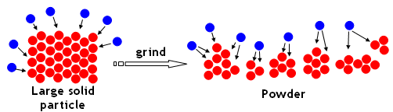
Increasing surface area increases the frequency of collisions, increasing reaction rate.
For example, when starting a campfire, it is easier to start with small kindling. This increases the wood's surface area and burning is much easier and faster. We also chop the wood to increase surface area, rather than adding whole logs to a fire.

