The Collision Theory
The collision theory states:
In order for a chemical reaction to occur, the reacting particles (molecules &/or atoms) must collide with each other. If the particles do not collide, no reaction occurs.
However, not all collisions produce a reaction.
The particles must collide with the correct orientation. Consider the following example:
In the atmosphere, ozone is converted to oxygen gas and nitrogen dioxide by reacting with nitrogen monoxide, according to the following reaction.
NO(g) + O₃(g) → NO₂(g) + O₂(g)
If the oxygen atoms collide in orientation (a), no reaction occurs. But if the nitrogen atom collides with the oxygen atom (b), a reaction occurs.
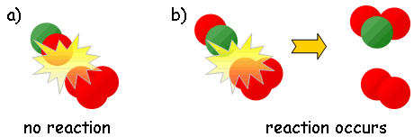

Activation Energy
Not only do particles need collide with the correct orientaion or reaction geometry, they must also collide with enough energy.
Chemical reactions involve the making and breaking of bonds, which requires energy. If colliding particles do not have sufficient velocity (Kinetic Energy) they will not produce a reaction.
The minimum amount of energy required for colliding particles to produce a chemical reaction is called the Activation Energy (E_{A}) of that reaction.
The greater the activation energy, the slower the reaction rate, the longer the reaction takes.
For example, hydrogen and oxygen can be kept in the same container at room temperature without a reaction occurring. Even though the molecules collide, they do not possess activation energy. If the mixture is heated to 800°C, or a flame or spark is introduced, an explosive exothermic reaction occurs. The heat, flame or spark provides enough energy for the particles to reach activation energy. They are able to strike each other with enough energy to break the hydrogen-hydrogen and oxygen-oxygen bonds.

Kinetic Energy Distribution
You may recall from grade 11 chemistry that James Clerk Maxwell and Ludwig Boltzman did experiments in 1866 which demonstrated that not all particles at a specific temperature had exactly the same velocities. In fact, some moved quite slowly, while others moved very quickly. Most, however, fell somewhere in between.
Maxwell and Boltzman also found that the velocities of these particles were directly related to the amount of Kinetic Energy (EK) they possessed. They plotted a curve to reflect the amounts of kinetic energy possessed by the particles. This curve is known as a Maxwell-Boltzman Curve or a Kinetic Energy Distribution Curve.
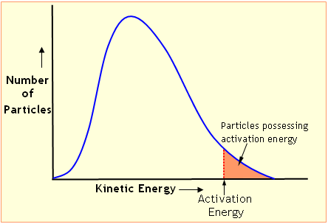
The area under the curve represents the number of particles at a given kinetic energy.
The area under the curve to the right of the activation energy represents the number of particles with sufficient energy to produce a reaction capable of a reaction. Each reaction has its own specific activation energy. The lower the activation energy, the more particles in the system that possess enough energy to produce a reaction.

Heat of Reaction
The rate of a reaction is determined by the height of the barrier that the particles must cross in order that they are converted into products.
The activation energy is the barrier colliding particles must overcome.
As the particles collide, they form an unstable intermediate particle called the activated complex or transition state. The energy required to produce the activated complex is the activation energy. The activated complex has a maximum amount of potential energy but exists for a very small instant in time.
Enthalpy (H) is the heat content or total energy possessed by the particles in a system.
The energy released or absorbed by a reaction is called the change in enthalpy, ΔH, or heat of reaction.
ΔH = H_{PRODUCTS} - H_{REACTANTS}
where ΔH is the change in enthalpy or energy that occurs during a reaction in Joules (J).
If ΔH is negative, the products have less enthalpy (energy) than the reactants. As a result heat flows out of the system. This type of reaction gives off heat and the reaction vessel feels warmer. This is called an exothermic reaction.
If ΔH is positive , heat is absorbed or flows into the system because the products have more enthalpy than the reactants. The reaction vessel feels cooler as energy is absorbed from the surroundings. This type of reaction is called an endothermic reaction.

Potential Energy Diagrams
A reaction coordinate diagram, or potential energy (EP) diagram or reaction progress diagram represents the energy change that occurs during a chemical reaction.
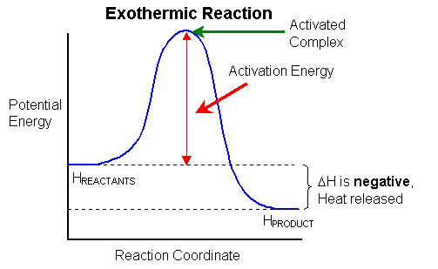
In the exothermic reaction, the products possess less energy than the reactants. During the reaction, heat is lost from the system and ΔH is a negative value.
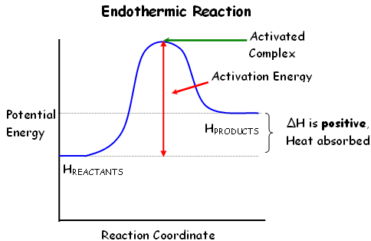
In an endothermic reaction, the products possess more potential energy than the reactants. This energy is absorbed from the surroundings, increasing the systems energy content, giving a positive ΔH value.
Reaction coordinate or potential energy diagrams provide a picture of the energy changes which occur as a chemical reaction proceeds. The reaction coordinate axis can be time or any other means of measuring reaction progress.
The energy changes during a chemical reaction are much the same as those occurring during a roller coaster ride. The beginning of a roller coaster ride is a long, slow, uphill ride. Energy is expended by motors, in the effort to get the cars to the top of the first hump. Once the cars reach the top of the first hump, it's all down hill. The cars have enough energy for the entire ride, regardless of the number of ups, downs, twists and turns.
In a chemical reaction, energy is added to overcome the activation energy, and to form the activated complex. Once the activated complex is formed the reaction proceeds along. Just as with the roller coaster ride, if the cars do not make it to the top of the first hump, the ride does not occur, and there are several disappointed (or relieved) riders. If particles do not possess the necessary energy, activation energy, to produce the activated complex, the reaction does not occur.
Let's look at the potential energy diagram for the formation of water from hydrogen and oxygen:
2 H₂ + O₂ → 2 H₂O
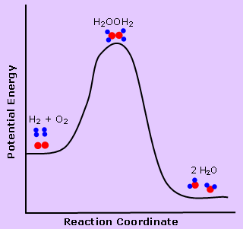
Hydrogen and oxygen can exist together without exploding or burning due to the need to overcome activation energy. The activation energy is high because of the need to break covalent hydrogen-hydrogen bonds in hydrogen molecules and oxygen-oxygen bonds in oxygen molecules. Notice that the transition state or activated complex is a single particle. This H₂OOH₂ particle does not last very long, but must be formed in order for hydrogen to burn. You should also notice that the enthalpy of water is lower then the enthalpy of hydrogen and oxygen molecules. The energy lost in the formation of water is released in the form of heat and light energy. All combustion reactions are exothermic.
Example 2
In the reaction,
CH₃CH₂Br + OH⁻ → CH₃CH₂OH + Br⁻
the reaction coordinate diagram is shown below:
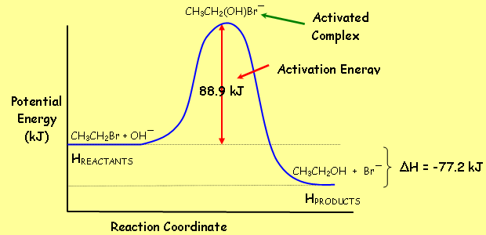
The activated complex in this reaction is CH₃CH₂(OH)Br⁻. It is a single particle formed by the all the reactant particles.
The activation energy is 89.5 kJ per mole of CH₃CH₂Br.
The enthalpy change is −77.2 kJ, indicating an exothermic reaction. Consequently, this reaction does not take place unless 88.9 kJ per mole of CH₃CH₂Br is added to the system.

