Analysing Results
The graph from Part B in Lesson 1 Exercises is shown below:
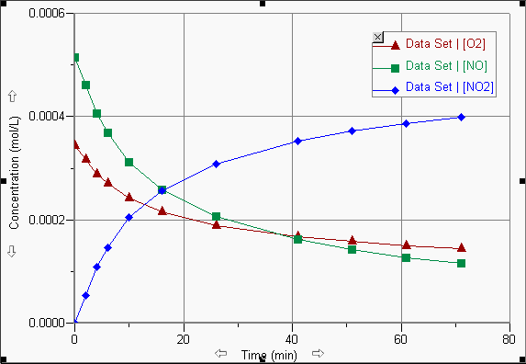
The equation for this reaction is O₂(g) + 2 NO(g) → 2 NO₂ (g).
If we examine the graph, the concentration of the NO₂ increases about the same amount as the NO decreases and the concentrations of the NO and NO₂ change about twice the amount that the O₂ changes.
If we look at the rate data, the initial rate of consumption of NO is about 2.65 × 10⁻⁵ mol/Ls and O₂ is 1.3 × 10⁻⁵ mol/Ls; the rate for NO is twice the O₂. The initial rate of formation of NO₂ is equal to the rate of consumption of NO and twice that of the O₂.
Look at all the other rate calculations. You should see that this pattern is maintained. These ratios are the same ratios as those found in the reaction stoichiometry. We can write this in our rate equation as shown below:
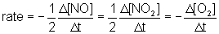
or
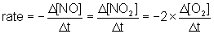
Rate and Stoichiometry Problems
Example 1. The decomposition of nitrogen dioxide occurs according to the equation below.
2 NO₂ → O₂ + 2 NO
If the rate of decomposition of NO₂ is determined to be 0.50 mol/Ls at a certain temperature, predict the rate of creation of both products.
Solution:
Use the molar ratios to determine rates.
We can solve this problem in a similar manner to how we solved stoichiometry problems in grade 11 chemistry.
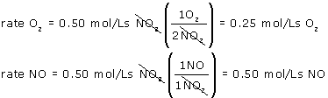
Example 2. For the reaction 2 A + B → 3 C, what is the rate of production of C and the rate of disappearance of B if A is used up at a rate of 0.60 mol/Ls?
Solution:
Use the molar ratios to determine rates.
by using the molar ratio of A to C we can make the equation:
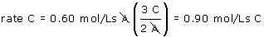
by using the molar ratio of A to B we get:
