What is Rate?
Recall that a chemical reaction is one in which a new substance is formed. They are usually expressed in the shorthand form, known as a chemical equation.
The chemical equation has reactants, usually written on the left side of an arrow, and the products of the reaction, written on the right side of the arrow, as below:
REACTANTS → PRODUCTS
The rate of a reaction refers to the speed with which a chemical reaction takes place. That is, how fast reactants are used up or products are formed.

Measuring Rate
How do we usually measure the how fast a reaction occurs?
Generally, we will measure the rate of a reaction by how much time it takes to go to completion – slower reaction take a longer period of time. For example, an explosion is a very fast reaction because the explosive burns up in fractions of a second, while burning the wax in a candle could take hours. But the term fast or slow is relative. For example, the oxidation of the steel on my car, or rusting, is actually a fairly slow reaction compared to reactions like burning matches or frying eggs or baking a cake, but every time I wash my car I think to myself, “boy, is my car rusting fast!” Chemists need a more consistent means of measuring the rate of a chemical reaction for comparisons and in order to manipulate the rates.
In grade 10 science, you learned that speed or velocity can also be called the rate of motion. When we measure rate of motion, we measure the change in position or distance over a period of time. We use these values to determine the speed or velocity by the equation below:
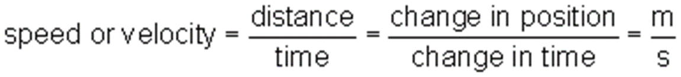
Speed can also be measured in kilometres per hour (km/h) or miles per hour (mph). The word “per” always refers to division. So, kilometres per hour means kilometres travelled divided by hours travelled.
Reaction rate is measured by determining the change in the amount of reactant consumed or product created in a period of time. The actual amounts of these may not be able to be directly determined, so another observable property must be measured. The rate of a reaction is
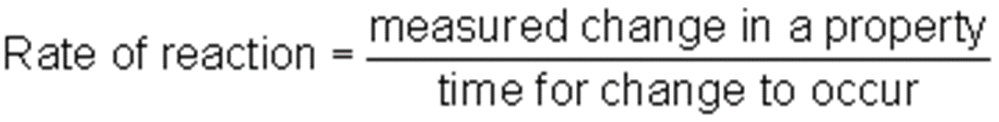
Rate can be measured using several different methods.
The reaction below shows that A and B combine to form C and D and heat is given off. Also, substance B has a green colour in solution and D has a red colour in solution.
A(s) + B(aq) → C(g) + D (aq) + heat
In this reaction, rate can be measured in terms of several different properties:
i) Temperature change over time (°C/min)
As the reaction proceeds, the system will increase in temperature. The faster heat is produced, the higher the rate
ii) Pressure change over time (kPa/s or mmHg/s)
As the reaction proceeds, more gaseous C is produced. This increases the pressure of the system. The faster the pressure increases, the greater the rate.
iii) Mass change over time (g of C/min)
As the reaction proceeds, reactants are used up and converted to gas. This results in a loss of mass of reactants, or an increase in mass of product, C.
iv) Colour change over time
Colour change is usually measured in terms of how much light of a specific wavelength can be absorbed. The amount of absorbance can be directly related to the concentration. The greater the concentration of D, the deeper the red colour and the more light that is absorbed.
v) Others
pH change, change in conductivity, etc. over a period of time.

Calculating Average Rate
The rate of a reaction is often described in terms of the change in concentration of the reactants or the products.
The average rate of a reaction is the change in concentration (or other property) over a period of time. For the equation
A → B
The average rate can be expressed mathematically as
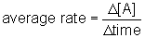or 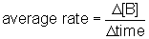
Chemists often use the square brackets to mean “concentration of” the substance in the brackets.
The Δ or the Greek letter delta means “change in”.
We can write this equation in another way, as well:
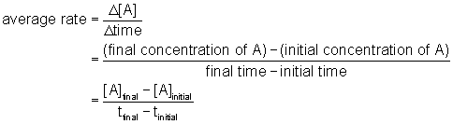

Calculating Average Rate
Let's look at the following example:
Example 1. According to the reaction A → B, the following data was collected:
Time (s) | Concentration of B (mol/L)
0.0 | 0.0
10.0 | 0.30
20.0 | 0.50
30.0 | 0.60
40.0 | 0.65
50.0 | 0.67
a) What is the average rate over the entire 50 seconds?
b) What is the average rate for the interval 20 s to 40 s?
Solution
a) recall, rate is a change over time
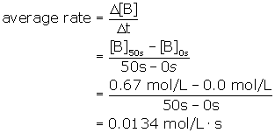
The units for rate can be written as mol/L/s, mol/Ls, mol L⁻¹s⁻¹, or 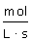.
The time term will change depending on the time units used.
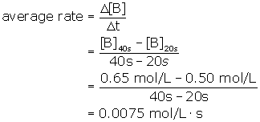
b)

Example 2. The decomposition of nitrogen dioxide produces nitrogen monoxide and oxygen according to the reaction:
2 NO₂(g) → 2 NO(g) + O₂(g)
the following data has been collected:
Time  (s) | [NO₂]  (mol/L | [NO]  (mol/L) | [O2]  (mol/L)
0.0 | 0.100 | 0.00 | 0.00
100 | 0.066 | 0.034 | 0.017
200 | 0.048 | 0.052 | 0.026
300 | 0.038 | 0.062 | 0.031
400 | 0.030 | 0.070 | 0.035
Calculate the average rate of decomposition of NO₂ over 400 s.
Solution:
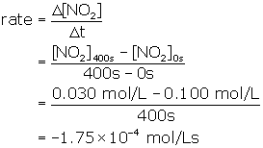
Note that the calculated rate is a negative number. Rate is always expressed as a POSITIVE value. The actual value of the average rate is 1.75×10⁻⁴ mol/Ls.
We should rewrite the equation for the average rate of a reactant with a negative sign as shown below:
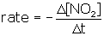

Instantaneous Rate
Reactions often start quickly, but slow down over time. You have noticed this if you light a match. The match starts quickly, but the flame slowly diminishes until it goes out. We will discuss why this occurs later.
If we graph the change in concentration of reactants or products versus time we find that the graphs are not linear.
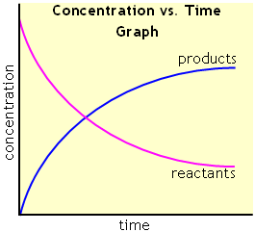
The shape of the curves suggests that the rate does not stay constant throughout the reaction.
The instantaneous rate is the rate at an instant in time, while the average rate describes the rate over an interval. The difference between these can be explained in an analogy of driving from Winnipeg to Brandon (about 200 kilometers). If it takes you 2 hours to drive from Winnipeg to Brandon, what is your average speed (rate of motion)? Driving 200 km over 2 hours would result in an average speed of 200 km ÷ 2 hours = 100 km/h. But, you do not travel at 100 km/h at every moment. There are times where you must stop for a light or a train. There are places where the speed limit is below 100 km/h, so you slow down. There are also places where you may exceed the 100 km/h speed limit (I am not, however, condoning speeding). At any one instant your speed may be different than your average speed.
Unfortunately chemical reactions do not have speedometers for us to determine the instantaneous rate. In order to determine the instantaneous rate we must first draw a concentration (or other property like pressure or mass) vs. time graph.
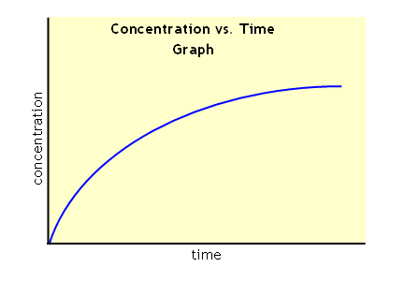
Then you determine at which time you wish to find the rate. Draw a line to the concentration vs. time curve.
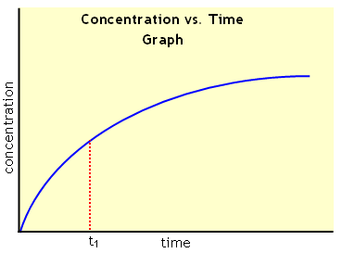
Draw the tangent line to that point on the curve. A tangent is a line drawn to a curve that touches the curve at only one point. If we imagine the curve is part of a circle, the tangent is also perpendicular to the radius of the circle.
The instantaneous rate at time t₁ is the slope of the tangent drawn to that point.
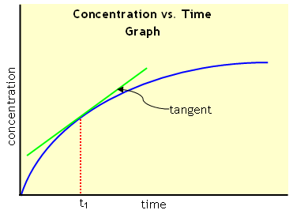
Drawing a tangent by hand can be rather difficult and have a lot of variation. Fortunately, there is graphing software that can draw a tangent line and determine its slope.

